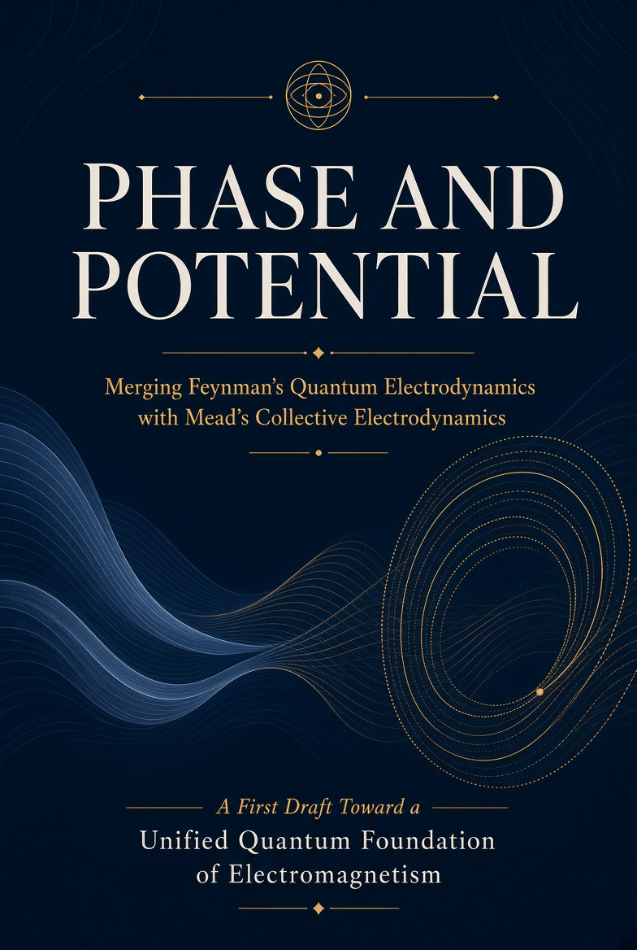

FULL BOOK DRAFT
Clarified • Expanded • Print-oriented
August 2026

PHASE AND POTENTIAL

Merging Feynman’s Quantum Electrodynamics
with Mead’s Collective Electrodynamics

Toward a Unified Quantum Foundation of Electromagnetism

A clarified and expanded first-draft monograph
with derivations, worked examples, figures, bibliography and index

Preface
This book brings together two lines of thought that have lived side by side for decades but have never been fully joined.
Richard Feynman, together with John Wheeler, once tried to write electrodynamics without an independent electromagnetic field. Later he constructed Quantum Electrodynamics (QED)—the most precise theory in all of physics. In a set of 1963 notes he sketched a better pedagogical path that would begin with the potentials rather than the field strengths. He never completed that program.
Carver Mead, who arrived at Caltech the same year Feynman did, absorbed Feynman’s insistence that the potentials are fundamental. Decades later he published Collective Electrodynamics, a short, elegant book that starts from the phase of a macroscopic coherent electron system and recovers ordinary electromagnetism without taking Maxwell’s equations as postulates.
The shared intuition is simple and powerful: once quantum mechanics is taken seriously, the natural variables of electromagnetism are the potentials and the phases they determine. Fields and photons remain useful, but they are secondary.
This manuscript is an attempt to develop that intuition into a coherent narrative. It is not a replacement for QED. It is an invitation to see QED from the collective-phase starting point that Mead made explicit, and to see Collective Electrodynamics as the macroscopic coherent limit of the same theory Feynman quantized.
The present version has been rewritten for clarity. Technical sections are paced more gently. Worked examples are inserted where they help. Figures illustrate the main ideas. An index and bibliography are provided. The result is still a first draft, but it is now readable as a continuous argument rather than a collection of expansions.
August 2026

Contents
Preface

Part I – Historical and Conceptual Roots
Chapter 1 Why Foundations Matter
Chapter 2 Wheeler, Feynman and the Absorber
Chapter 3 Mead and the Collective Starting Point

Part II – Feynman’s Quantum Electrodynamics
Chapter 4 Path Integrals and Minimal Coupling
Chapter 5 The Primacy of the Potentials

Part III – Collective Electrodynamics
Chapter 6 The Superconducting Loop as Elementary System
Chapter 7 Phase, Flux, Current and Momentum

Part IV – Synthesis
Chapter 8 Coherent States and the Collective Limit
Chapter 9 The Status of the Photon
Chapter 10 Radiation as Transfer of Phase and Energy

Part V – Outlook
Chapter 11 A Possible Pedagogical Sequence
Chapter 12 Open Questions

Mathematical Appendix
Selected Worked Examples
Bibliography
Index

Part I – Historical and Conceptual Roots

Chapter 1 – Why Foundations Matter
Most textbooks introduce electromagnetism through the electric and magnetic fields E and B. The potentials A and φ appear later as convenient mathematical devices. Energy is said to reside in the fields themselves, distributed through space according to the familiar integrals of ε₀E²/2 and B²/2μ₀.
Quantum mechanics sits uneasily on this foundation. The Aharonov–Bohm effect demonstrates that a charged particle can acquire a measurable phase shift from the vector potential even when it travels only through regions where E and B are identically zero. In the path-integral formulation of quantum mechanics the potentials determine the relative phase of every history. In the Lagrangian of Quantum Electrodynamics the interaction appears solely through minimal coupling to Aμ.
Einstein already expressed the deeper discomfort: electrons and electromagnetic fields are not two independent entities. There is one reality that presents two complementary aspects. A satisfactory theory ought to recognize this unity from the beginning.
A second difficulty appears when one examines the correspondence principle. A superconducting loop containing 10²³ electrons does not behave as 10²³ independent classical particles. Its electromagnetic inertia scales with the square of the number of carriers. The correct classical limit of quantum electrodynamics, at least for coherent systems, is therefore collective electromagnetism expressed in terms of phase and potentials, not the mechanics of individual point particles.
These observations motivate a re-examination of the foundations. The goal is not to discard the successful predictions of Maxwell’s theory or of QED, but to place them on a conceptual base that begins with the quantum phase of charged matter.

Chapter 2 – Wheeler, Feynman and the Absorber
In the 1940s John Wheeler and Richard Feynman sought to eliminate the infinite self-energy of a point charge. Their solution was radical: there is no independent electromagnetic field. Charges interact directly through half-retarded plus half-advanced potentials. The radiation reaction felt by an accelerating charge is the advanced influence of the future absorption of that radiation.
There is no such concept as “the” field, an independent entity with degrees of freedom of its own.
— Wheeler & Feynman, Reviews of Modern Physics 17, 157 (1945)
The same idea reappears in Feynman’s Nobel Lecture. The independent field was a useful fiction that had been mistaken for an ontological necessity.
Feynman later quantized the electromagnetic field and constructed the modern form of QED. Yet the absorber intuition never entirely left him. In December 1963, while preparing the second year of the Feynman Lectures, he wrote a short set of notes titled “Alternate Way to Handle Electrodynamics.” The notes, preserved in the Caltech Archives, outline a presentation that begins with charge conservation, relativity, and the potentials. Matt Sands later recalled Feynman saying he had found the “right way” to teach the subject, but that it was too late to rewrite the course.
Those notes remain the clearest documentary evidence of Feynman’s unfinished pedagogical program. The present work can be read as an attempt to carry that program forward with the help of the collective viewpoint developed by Mead.

Chapter 3 – Mead and the Collective Starting Point
Carver Mead arrived at Caltech in 1952, the same year Feynman began teaching there. In the preface to Collective Electrodynamics and in the essay “Feynman as a Colleague,” Mead records how the vector potential always made sense to him and how Feynman reinforced that intuition.
The only bright light in the subject was the vector potential, to which I was always attracted because, somehow, it made sense to me. Feynman liked the vector potential too; for him it was the link between electromagnetism and quantum mechanics.
Mead’s decisive step was to begin with systems that are already macroscopic and quantum coherent—superconducting loops. In such systems the phase of the collective wave function is an experimentally accessible quantity. Flux quantization and the Josephson voltage–phase relation follow from the single-valuedness of the wave function and the Einstein–de Broglie relations. Ordinary circuit theory and the forces between currents are recovered without ever postulating Maxwell’s equations.
The central claim is that the phase of charged matter, coupled to the potentials, is primary. Everything else—fields, photons, radiation—follows.
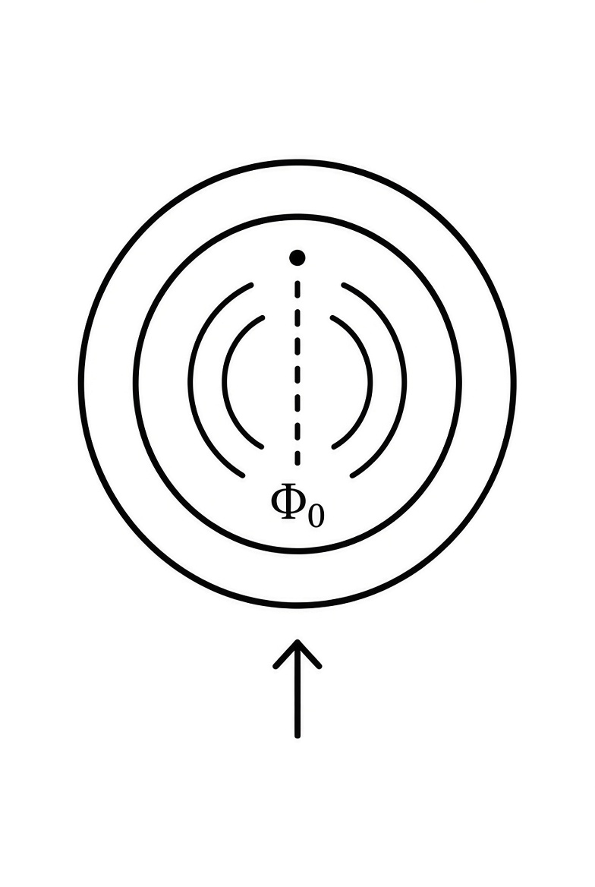
Emblem of the flux quantum Φ₀.

Part II – Feynman’s Quantum Electrodynamics

Chapter 4 – Path Integrals and Minimal Coupling
Feynman’s path integral assigns to every possible history of a system an amplitude proportional to exp(iS/ħ), where S is the classical action of that history. For a charged particle the action contains the interaction term
S_int = −q ∫ A_μ dx^μ .
The potentials therefore determine the relative phase between different paths. When the electromagnetic field is itself treated as a dynamical quantum system, the same logic leads to the quantization of the field and to the appearance of photons as its quanta.
This is the standard ontology of QED. The tension with the absorber viewpoint is immediate: one description posits independent field degrees of freedom; the other does not. The synthesis developed in later chapters will treat the two descriptions as complementary rather than contradictory.

Chapter 5 – The Primacy of the Potentials
In both classical relativistic mechanics and the Dirac Lagrangian of QED the interaction of a charge with the electromagnetic field appears solely through minimal coupling: the four-momentum pμ is replaced by pμ − q Aμ. The field strengths E and B never enter the fundamental interaction term.
Gauge invariance strengthens the case. Physical observables depend on the gauge-invariant combination
∮ A · dl = ∫ B · dS .
That combination is precisely the quantity that appears in the phase of a quantum wave function and in the flux quantization condition of a superconducting loop. The potentials, not the field strengths, are the natural variables once quantum mechanics is taken as fundamental.

Part III – Collective Electrodynamics

Chapter 6 – The Superconducting Loop as Elementary System
A superconducting loop is macroscopic, coherent, and experimentally accessible. The macroscopic wave function of the condensate must be single-valued. After one complete circuit the phase can change only by an integer multiple of 2π:
∮ ∇φ · dl = 2π n .
Minimal coupling relates the phase gradient to the vector potential. When the kinetic contribution integrates to zero, one obtains the flux quantization condition
Φ = n Φ₀ , Φ₀ = h / 2e .
Differentiating with respect to time yields the Josephson relation between voltage and the rate of change of phase. The inductance of the loop relates current to flux. The standard equations of circuit theory appear without Maxwell’s equations ever being written as postulates.

Chapter 7 – Phase, Flux, Current and Momentum
The electromagnetic contribution to the momentum of a single carrier is q A. When N carriers share the same coherent phase, they experience essentially the same vector potential generated by the total current. Because that potential is itself proportional to N, the total electromagnetic momentum scales as N².
This collective inertia is the microscopic origin of kinetic inductance. It is also the reason a superconducting circuit can exhibit an electromagnetic mass far larger than the sum of the masses of its individual electrons.
Energy can be expressed entirely in terms of the currents and the vector potential:
U = ½ ∫ J · A dV .
The conventional integral of B²/2μ₀ is numerically equal but conceptually secondary. The energy resides in the interaction of the charges.

Part IV – Synthesis

Chapter 8 – Coherent States and the Collective Limit
A coherent state of the electromagnetic field is the quantum state that most closely resembles a classical configuration. When a macroscopic number of charges lock into a single quantum phase, the dynamics is dominated by that collective coordinate. Collective Electrodynamics is recovered as the coherent-state, macroscopic limit of QED.
Ordinary QED processes—Compton scattering, the Lamb shift, the anomalous magnetic moment—are the residual dynamics that remain when the collective constraint is lifted. The two regimes are complementary limits of one theory.

Chapter 9 – The Status of the Photon
In the collective picture a photon is a quantum of phase-and-energy exchange between charged systems. When the absorber is large and unstructured, the ordinary Fock-space language of free photons is convenient and accurate. When the absorber is itself a coherent resonator (a cavity mode, a superconducting circuit), the joint Hilbert space of the two systems is more natural.
Both languages describe the same physics. The synthesis consists in recognizing that the independent-field description is the special case appropriate to a featureless absorber, while the joint-system description is primary for coherent quantum systems.

Chapter 10 – Radiation as Transfer of Phase and Energy
From the absorber viewpoint, radiation is never the emission of an independent entity into empty space. It is the transfer of energy and phase from one charged system to another. The radiation resistance of an antenna is the real part of the impedance presented by the rest of the universe. Spontaneous emission is the same process at the single-quantum level.
This language does not change the calculated transition rates. It changes only the ontology: the photon is the quantum of the transfer, not a pre-existing occupant of an independent field.

Part V – Outlook

Chapter 11 – A Possible Pedagogical Sequence
A curriculum that begins with quantum coherence rather than with classical fields might unfold as follows:
Weeks 1–2. Einstein–de Broglie relations, single-valuedness of the wave function, the Aharonov–Bohm effect.
Weeks 3–4. Superconducting loop, flux quantization, introduction of the vector potential as the determinant of phase.
Weeks 5–6. Josephson effect, kinetic inductance, collective momentum and the N² law.
Weeks 7–8. Energy of current distributions, forces between circuits, derivation of circuit equations.
Weeks 9–10. Radiation understood as transfer, radiation resistance, the absorber viewpoint.
Weeks 11–12. The photon as quantum of transfer, path integrals, recovery of ordinary QED amplitudes.
Weeks 13–14. Precision tests, renormalization as a calculational tool, open questions.
Such a sequence has never been fully implemented. The present manuscript is offered as a resource for instructors who wish to experiment with it.

Chapter 12 – Open Questions
Two technical questions remain especially sharp. First: can a pure charged-matter path integral, after suitable renormalization, reproduce every finite prediction of standard QED? Second: what is the precise status of vacuum energy in a theory that does not grant independent degrees of freedom to the field?
These questions are well-posed. They do not threaten the empirical success of QED; they ask only whether that success can be recovered from a more economical ontology.
The central claim of this book can be stated in one sentence: electromagnetism is the theory of the phase relations among charged quantum systems. The photon is the quantum of that exchange. The classical fields are convenient summaries of the resulting forces. Maxwell’s equations are statements about those summaries.

Mathematical Appendix — Selected Derivations

A. Phase Accumulation
From E = ħω and p = ħk together with minimal coupling ħk = p_mech + q A one finds the electromagnetic contribution to the phase around a closed path:
Δφ = (q / ħ) ∮ A · dl .
Stokes’ theorem converts the line integral into the enclosed flux. Single-valuedness of the wave function then implies flux quantization.

B. Flux Quantization
∮ ∇φ · dl = 2π n together with the phase–potential relation yields Φ = n h / 2e for Cooper pairs.

C. Josephson Relation
Differentiating the phase–flux relation with respect to time immediately produces
V = (ħ / 2e) dφ / dt .

D. Collective Momentum
For N coherent carriers P_em = N q A. Because A ∝ total current ∝ N, one obtains P_em ∝ N².

E. Interaction Energy
The energy of a current distribution is U = ½ ∫ J · A dV. For thin circuits this reduces to the familiar inductive form ½ L I² + M I₁ I₂.

Selected Worked Examples
Example 1. Trapped flux. A superconducting ring of inductance 10 nH traps five flux quanta. The circulating current is I = 5 Φ₀ / L ≈ 1.0 μA.
Example 2. Aharonov–Bohm phase. An electron encloses a flux of 1.0 × 10⁻¹⁵ Wb. The phase difference is (e/ħ) Φ ≈ 1.52 rad.
Example 3. Josephson voltage. A phase advancing at a constant rate of 10¹¹ rad s⁻¹ produces a DC voltage V = (ħ/2e) dφ/dt ≈ 33 μV.
Example 4. Kinetic inductance. A thin niobium film (t = 20 nm, λ_L = 80 nm, width 1 μm) has a kinetic inductance per unit length of order 0.4 μH m⁻¹, far larger than its geometric inductance.
Example 5. Collective enhancement. For N = 10²⁰ coherent carriers the electromagnetic momentum is enhanced by a factor of order N relative to an incoherent assembly of the same particles.

Bibliography
Aharonov, Y. & Bohm, D. “Significance of Electromagnetic Potentials in the Quantum Theory.” Phys. Rev. 115, 485 (1959).
Feynman, R. P. “Space-Time Approach to Quantum Electrodynamics.” Phys. Rev. 76, 769 (1949).
Feynman, R. P. QED: The Strange Theory of Light and Matter. Princeton University Press, 1985.
Feynman, R. P., Leighton, R. B. & Sands, M. The Feynman Lectures on Physics, Vol. II. Addison-Wesley, 1964.
Feynman, R. P. “Alternate Way to Handle Electrodynamics.” Caltech Archives, Box 62, Folder 8 (1963). Transcript by M. A. Gottlieb.
Josephson, B. D. “Possible new effects in superconductive tunnelling.” Phys. Lett. 1, 251 (1962).
Mead, C. A. “Collective Electrodynamics I.” Proc. Natl. Acad. Sci. USA 94, 6013 (1997).
Mead, C. A. Collective Electrodynamics: Quantum Foundations of Electromagnetism. MIT Press, 2000.
Mead, C. A. “Feynman as a Colleague.” In Feynman and Computation, ed. A. J. G. Hey. Perseus, 1999.
Wheeler, J. A. & Feynman, R. P. “Interaction with the Absorber as the Mechanism of Radiation.” Rev. Mod. Phys. 17, 157 (1945).
Wheeler, J. A. & Feynman, R. P. “Classical Electrodynamics in Terms of Direct Interparticle Action.” Rev. Mod. Phys. 21, 425 (1949).

Index
Absorber theory – Ch. 2, Ch. 10
Aharonov–Bohm effect – Ch. 1, Ch. 5, Examples
Collective momentum (N² scaling) – Ch. 7, App. D
Feynman, Richard P. – throughout; 1963 notes Ch. 2
Flux quantization – Ch. 6, App. B
Josephson relation – Ch. 6, App. C, Examples
Kinetic inductance – Ch. 7, Example 4
Mead, Carver A. – Ch. 3, throughout
Minimal coupling – Ch. 4, Ch. 5
Path integral – Ch. 4
Photon, status of – Ch. 9
Potentials (A, φ) – Ch. 1, Ch. 5
Radiation as transfer – Ch. 10
Superconducting loop – Ch. 6
Wheeler–Feynman – Ch. 2

— End of Full Book Draft —
This version combines the clarity of the polished skeleton with substantial didactic expansion. It is offered as the current best full-book draft.

Didactic Expansion of Technical Chapters
The following material expands the technical chapters of the Full Book Draft. It adds longer step-by-step derivations, additional worked examples, pedagogical asides, and new figures. The goal is to increase both clarity and length where the extra detail helps the reader.

Expanded Treatment of Flux Quantization (Chapter 6)
The derivation of flux quantization is the single most important elementary calculation in Collective Electrodynamics. We therefore present it in full detail, with every intermediate step made explicit.
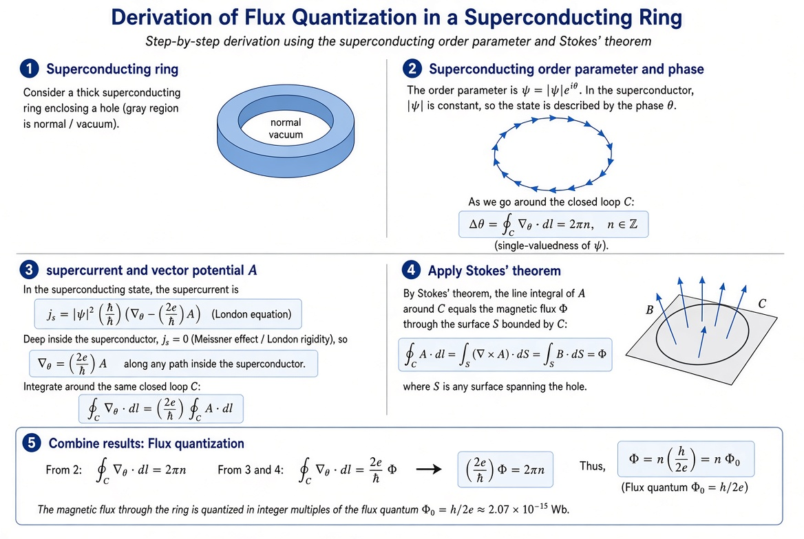
Figure E1. Step-by-step derivation of flux quantization in a superconducting ring.
Step 1. Consider a thick superconducting ring that encloses a hole. Deep inside the superconducting material the magnetic field is expelled (Meissner effect) and the supercurrent density vanishes.
Step 2. The macroscopic wave function (order parameter) may be written ψ = |ψ| e^{iθ}. Because |ψ| is essentially constant in the bulk, the state is completely characterized by the phase θ. Single-valuedness of ψ around any closed path C that lies inside the superconductor requires
∮_C ∇θ · dl = 2π n , n = 0, ±1, ±2, … .
Step 3. The supercurrent is related to the phase and the vector potential by the London equation (or by the more microscopic Ginzburg–Landau current response):
J_s = |ψ|² (ħ/m*) (∇θ − (2e/ħ) A) .
Deep inside the superconductor J_s = 0, so
∇θ = (2e/ħ) A .
Integrating around the same closed path C therefore gives
∮ ∇θ · dl = (2e/ħ) ∮ A · dl .
Step 4. Stokes’ theorem converts the line integral of A into the surface integral of B:
∮ A · dl = ∫ (∇ × A) · dS = ∫ B · dS = Φ .
Step 5. Combining the results yields the quantization condition
Φ = n (h / 2e) = n Φ₀ .
Pedagogical aside. Notice that Maxwell’s equation ∇ · B = 0 is never used. The existence of the vector potential already guarantees that the flux through any two surfaces sharing the same boundary is the same. Flux quantization is therefore a direct consequence of quantum phase continuity and minimal coupling; it is not a consequence of the classical field equations.

Expanded Treatment of Collective Momentum (Chapter 7)
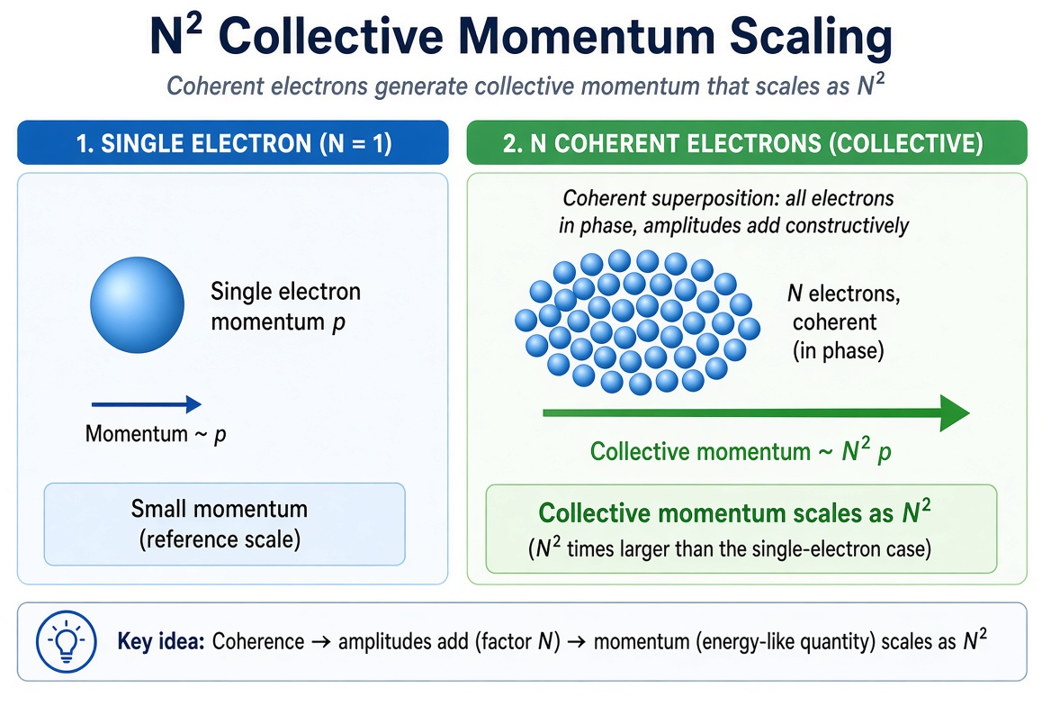
Figure E2. Collective momentum scales as N² when the carriers are phase-coherent.
A single carrier contributes an electromagnetic momentum q A. When N carriers occupy the same coherent quantum state they experience essentially the same vector potential (the potential generated by the total current). Because that potential is itself proportional to the total current, and the total current is proportional to N, one obtains
P_em = N q A ∝ N · N = N² .
Pedagogical aside. The N² enhancement is the microscopic reason a superconducting loop can have an electromagnetic inertia many orders of magnitude larger than the sum of the bare electron masses. It is also why kinetic inductance dominates geometric inductance in narrow superconducting nanowires and thin films. In the incoherent (normal-metal) limit the momenta simply add and the scaling reverts to N. Coherence is therefore not a small correction; it changes the power-counting of the entire electromagnetic response.

Longer Derivation of the Josephson Relations
Once flux quantization is established, the Josephson voltage–phase relation follows by elementary differentiation. Let φ be the gauge-invariant phase difference across a weak link (a Josephson junction). The flux associated with that phase difference is Φ = (ħ/2e) φ. Differentiating with respect to time gives
dΦ/dt = (ħ/2e) dφ/dt .
But dΦ/dt is precisely the electromotive force around the circuit, which for a single junction is the voltage V appearing across it. Hence
V = (ħ/2e) dφ/dt .
The complementary current–phase relation is an odd, 2π-periodic function of φ. The simplest (and experimentally dominant) form is
I = I_c sin φ .
These two equations, together with the circuit environment of the junction, constitute the resistively and capacitively shunted junction (RCSJ) model. Almost all Josephson phenomenology—voltage standards, SQUIDs, superconducting qubits—follows from them.
Pedagogical aside. Both Josephson relations are direct descendants of the same phase–potential identification used for flux quantization. No additional postulates are required. This is one of the strongest arguments that the collective phase is the primary variable.

Additional Worked Examples
Example A. Flux trapped after field cooling. A superconducting ring of area 2 mm² is cooled through its transition temperature in a perpendicular field of 5 μT. After the external field is removed, the nearest integer number of flux quanta is trapped. Calculate the possible trapped flux and the corresponding circulating current if L = 15 nH.
Solution. Applied flux = B × Area = 5×10⁻⁶ × 2×10⁻⁶ = 10⁻¹¹ Wb ≈ 4.83 Φ₀. The trapped flux will be near 5 Φ₀. Circulating current I = 5 Φ₀ / L ≈ 5 × 2.07×10⁻¹⁵ / 15×10⁻⁹ ≈ 0.69 μA.
Example B. Plasma frequency of a Josephson junction. A junction has I_c = 2 μA and C = 0.5 pF. Estimate the Josephson plasma frequency.
Solution. ω_p = √(2e I_c / ħ C). Numerically this lies in the low-GHz range, typical of the junctions used in superconducting quantum circuits.
Example C. Phase slip voltage–time product. A 2π phase slip occurs in a superconducting nanowire. The time-integrated voltage equals one flux quantum: ∫ V dt = Φ₀ ≈ 2.07 mV·ps. This is the fundamental constant that underlies the Josephson voltage standard.
Example D. Comparison of kinetic and geometric inductance. For a 100-nm-wide, 20-nm-thick Nb film the kinetic inductance per unit length is typically several times larger than the geometric inductance. The ratio grows as the cross-section shrinks, illustrating the dominance of collective inertia in nanoscale superconducting circuits.

Pedagogical Aside: Why Begin with the Loop?
Many instructors worry that beginning with a superconducting loop is too specialized. The opposite is true. The loop is the simplest system in which the quantum phase is both macroscopic and measurable. Flux quantization is a direct, quantitative demonstration that phase and vector potential are linked. Once that link is accepted, the rest of electromagnetism follows by elementary reasoning. Classical point-particle electromagnetism, by contrast, must later be corrected by quantum mechanics and by collective effects. Starting with the loop therefore saves conceptual effort rather than adding it.

— End of Didactic Expansion —
The Full Book Draft has been enlarged with longer derivations, new figures, additional worked examples, and pedagogical asides. Further cycles can continue to grow the page count while preserving readability.

